PURPOSE

The purpose of this program is to inform employees of the safety hazards associated with operations that may involve flammable gases and vapors.

- TYPES OF GAS HAZARDS

- Flammable: Risk of Fire and/or Explosion (i.e., Methane, Butane, Propane)

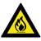

- Toxic: Risk of Poisoning (i.e., Carbon Monoxide, Hydrogen, Carbon Dioxide & Chlorine)

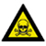

- Asphyxiant: Risk of Suffocation (i.e., Oxygen can be displaced by another gas)

- FLAMMABLE GAS HAZARDS

- Combustion is a fairly simple chemical reaction in which Oxygen is combined rapidly with another substance resulting in the release of energy. This energy appears mainly as heat – sometimes in the form of flames. The igniting substance is normally, but not always, a Hydrocarbon compound and can be solid, liquid, vapor or gas. However, only gases and vapors are considered in this publication.

- The process of combustion can be represented by the well-known
fire triangle.

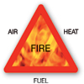

- Three factors are always needed to cause combustion:

- Oxygen
- Fuel (Gas or Vapor)
- A Ignition Source

- In any fire protection system, therefore, the aim is to always remove at least one of these three potentially hazardous items.

- FLAMMABLE LIMIT

- There is only a limited band of gas/air concentration which will produce a combustible mixture. This band is specific for each gas and vapor and is bounded by an upper level, known as the Upper Explosive Limit (or the UEL) and a lower level, called the Lower Explosive Limit (LEL).

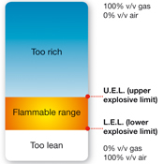

- At levels below the LEL, there is insufficient gas to produce an explosion (i.e. the mixture is too ‘lean’) or the mixture has insufficient Oxygen (i.e. the mixture is too ‘rich’). The flammable range therefore falls between the limits of the LEL and UEL for each individual gas or mixture of gases. Outside these limits, the mixture is not capable of combustion.

- FLAMMABLE GAS PROPERTIES

- Ignition Temperature: Flammable gases also have a temperature where ignition will take place, even without an external ignition source such as a spark or flame. This temperature is called the Ignition Temperature.

- Flash Point: The flash point of a flammable liquid is the lowest temperature at which the surface of the liquid emits sufficient vapor to be ignited by an ignition source.

- VAPOR DENSITY (Air = 1.0)

- If Vapor Density is < 1.0, The Gas Will Rise

- If Vapor Density is > 1.0, The Gas Will Fall

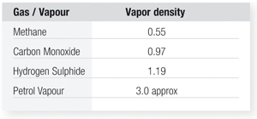

- TOXIC GAS HAZARDS

- Some gases are poisonous and can be dangerous to life at very low concentrations. Some toxic gases have strong smells like the distinctive ‘rotten eggs’ smell of H2S. The measurements most often used for the concentration of toxic gases are parts per million (ppm). For example 1ppm would be equivalent to a room filled with a total of 1 million balls and 1 of those balls being red. The red ball would represent 1ppm.

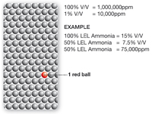

- More people die from toxic gas exposure than from explosions caused by the ignition of flammable gas. It should be noted that there is a large group of gases which are both combustible and toxic, so that even detectors of toxic gases sometimes have to carry hazardous area approval. The main reason for treating flammable and toxic gases separately is that the hazards and regulations involved and the types of sensor required are different.

- With toxic substances, (apart from the obvious environmental problems) the main concern is the effect on workers of exposure to even very low concentrations, which could be inhaled, ingested, or absorbed through the skin. Since adverse effects can often result from additive, long-term exposure, it is important not only to measure the concentration of gas, but also the total time of exposure.

- ASPHYXIANT HAZARD (OXYGEN DEFICIENCY)

- We all need to breathe the Oxygen (O2) in air to live. Air is made up of several different gases including Oxygen. Normal ambient air contains an Oxygen concentration of 20.9%. When the Oxygen level dips below 19.5%, the air is considered Oxygen-deficient. Oxygen concentrations below 16% are considered unsafe for humans.

- Oxygen depletion can be caused by displacement, combustion, oxidation, Or a chemical reaction.

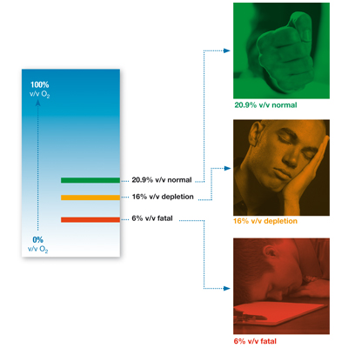

- OXYGEN ENRICHMENT

It is often forgotten that Oxygen enrichment can also cause a risk. At increased O2 levels the flammability of materials and gases increases. At levels of 24%, items such as clothing can spontaneously combust.

- MONITORING

The Company shall ensure that each employee utilizes a portable gas detector as required in all high gas hazard areas. All gas monitors shall be calibrated per manufacturer's recommendations and contain a current calibration sticker on the monitor providing the date of calibration. Additionally, “Bump Test” shall be completed at the beginning of each day to ensure the monitor is functioning correctly.

- EMPLOYEE TRAINING

- Gas hazard awareness training shall be provided to each employee before initial assignment and annually thereafter. Employees shall be made aware of the Client’s contingency plan provisions including evacuation routes and alarms. Employees shall participate in emergency evacuation drills and practice rescue procedures. Addtionally, “Gas Hazard Awareness” training shall include at a minimum:

- Gas Alarms,
- Locations of Alarm Stations,
- Gas Monitoring Equipment (Portable and Fixed Detection),
- Gas Hazards - Characteristics of gases, to include oxygen deficiency, oxygen or nitrogen enrichment, carbon monoxide and hydrogen sulfide at a minimum (Note: Hazard training must also include specific gases of concern as well as signs and symptoms of overexposure)
- Personnel Rescue Procedures
- Use and Care of Self-Contained Breathing Apparatus (SCBA), including Donning & Emergency Procedures
- Evacuation Procedures
- Staging Areas (Primary & Secondary)

- Gas Hazard Awareness training shall be documented and available for review by Clients and/or government agencies.

Reviewed and Approved
Quality Manager or President
Date

